Name: _____________________ /50


Yr 12 Physics Motion & Forces Test 2020

(50 minutes working time)

Instructions
- Answer all questions in the spaces provided.
- Give all numerical answers to three significant figures, except when you are required to estimate values where two significant figures will be appropriate.
- Show all working – marks may be awarded for logical working even when an incorrect final answer is arrived at.
- If you require extra working space, indicate this to your teacher who will give you some lined paper. Be sure to write your name on top and staple it to your test.

50 marks for answering the questions
Up to 4 marks maybe deducted for incorrect units and significant figures

QUESTION ONE (4 marks)
The diagram on the left shows a box of mass 100.0kg suspended by two cables. T1 is attached to a vertical wall at angle of 54.0⁰, while T2 is attached to another vertical wall at angle of 31.0⁰.
- Sketch a vector diagram of the situation (2 marks)

- Determine the tension T1 and T2 in the two cables (2 marks)

QUESTION TWO (5 marks)
The diagram on the left shows a ball of mass 0.156 kg held h metres above the ground. If h = 1.25m, determine the largest value of the radius, r, that the ball will successfully negotiate the loop without falling off (ie while maintaining circular motion).
Assume friction is negligible.
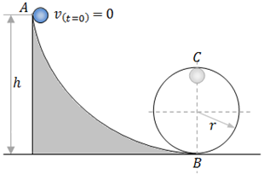

QUESTION THREE (4 marks)

By showing appropriate calculations, explain why NASA has found it impossible to place a satellite in geostationary orbit around the moon (1 Moon day is equivalent to 27 Earth days).

QUESTION FOUR (6 marks)

- A cyclist of mass 74.5 kg is riding a bicycle of 14.0 kg around a corner that is part of a circular road of radius 27.8 m. Determine the frictional force required for the rider to safely (ie no sliding) negotiate the corner at 31.5 km/h. (2 marks)

- Determine the new top speed that the same rider could safely negotiate the same corner at if it was banked at an angle of 17.8⁰ to the horizontal and the same surface friction as calculated in (a) is also available. (4 marks)
(If you didn’t get an answer for (a) then use 2.50 x 10² N)

QUESTION FIVE (5 marks)

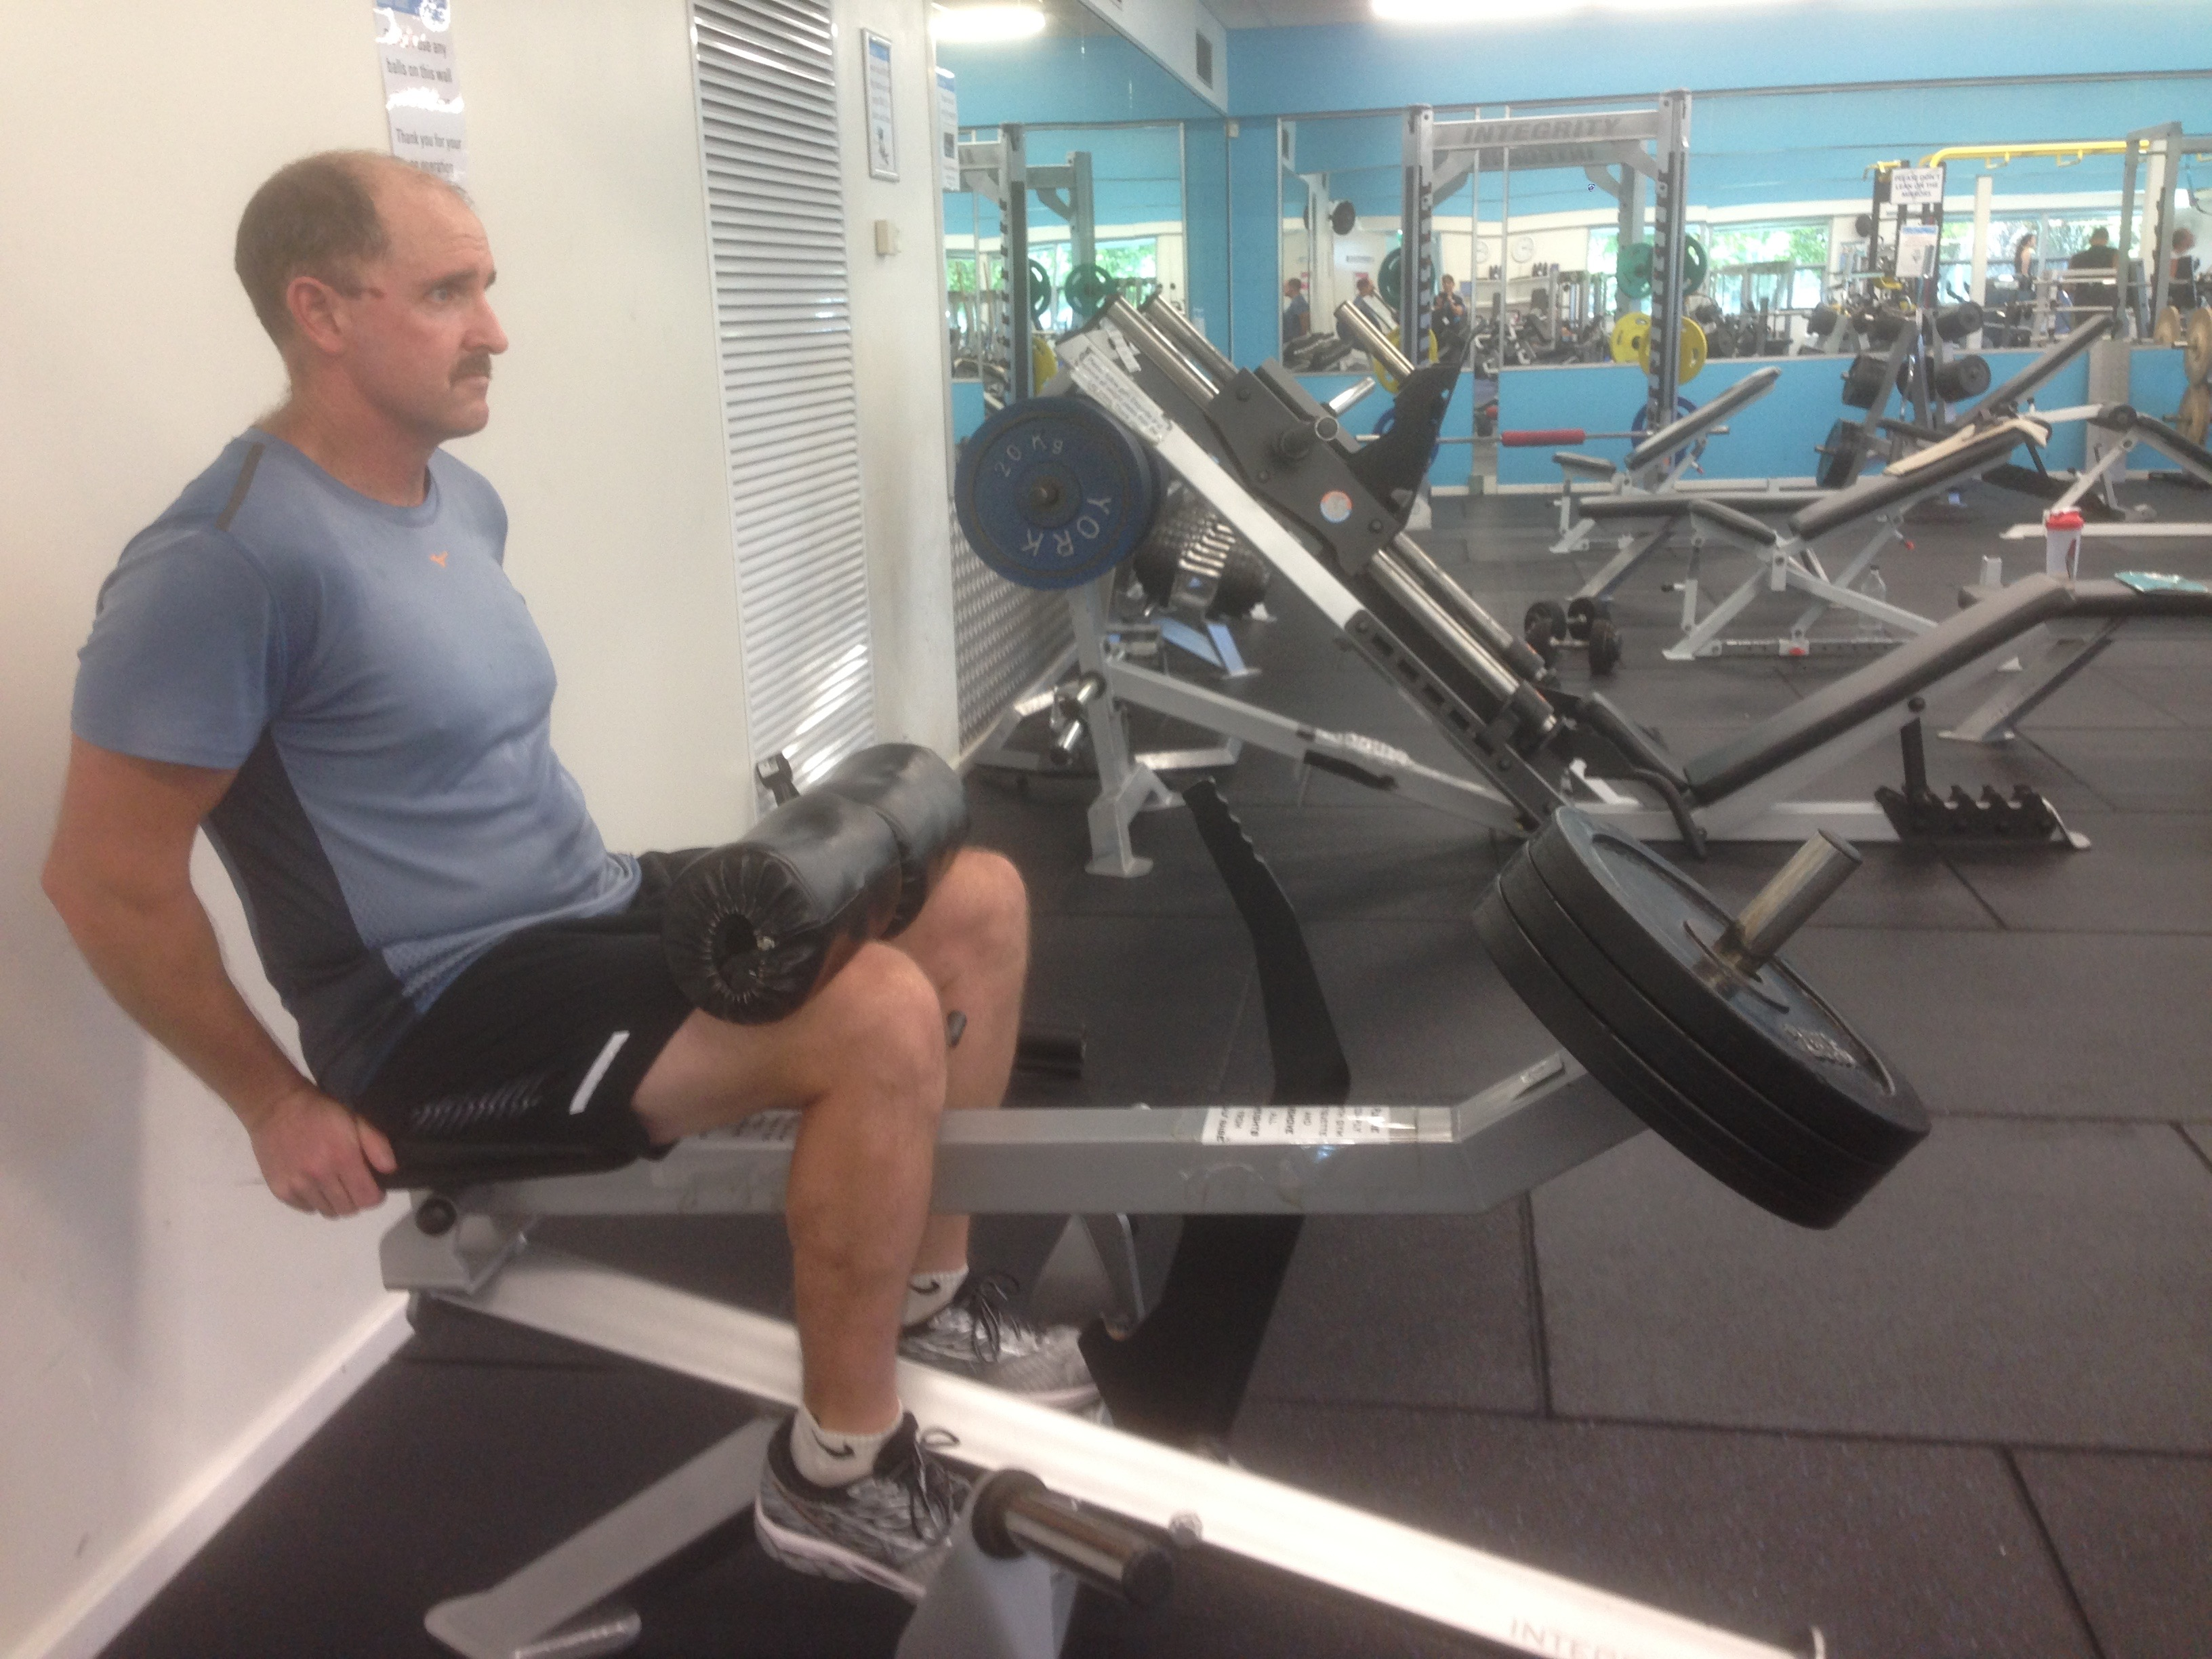
The photo on the left shows a man training his calf muscles. There is a 60.0kg load on the right hand end of a metal beam, which is hinged under the seat of the device. The load is lifted by the lower legs via two pads, one on each knee. By making appropriate estimations, determine the magnitude of the force exerted by each calf to support the 60.0kg load.
(Assume: weight of beam & knee pads are negligent; both the beam and the feet are horizontal; the lower legs are vertical).

QUESTION SIX (3 marks)

Planet | Mass (Earth masses)
Mercury | 0.0550
Venus | 0.815
Earth | 1.000
Mars | 0.107
Jupiter | 318
Saturn | 95.0
Uranus | 14.5
Neptune | 17.2
Pluto | 0.00200

Ganymede is the ninth largest object in the solar system and is the largest moon of Jupiter. It orbits at an average distance of 1.07 x 10⁶km from Jupiter. Use the Formulae and Data booklet and the data in the table on the right to determine the strength of Jupiter’s gravitational field where Ganymede orbits.

QUESTION SEVEN (10 marks)
A 12.0m boom, AB, of a crane supporting a 3.00 x 10³ kg load is shown on the left. The centre of mass of the boom is at its geometric centre, and the mass of the boom is 1.00 x 10³ kg. Assume the two angles shown are 10.0⁰ and 30.0⁰.

For the position shown, calculate

- The tension T in the cable (5 marks)

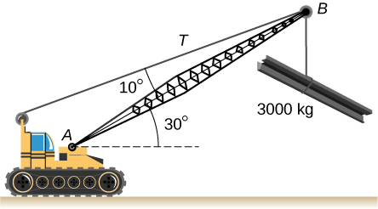

- the force of the axle on the boom at A (5 marks)

QUESTION EIGHT (13 marks)

A firework rocket was launched into the air from the ground at point A with an initial velocity of 30.0 m s⁻¹ at an angle of 70.0° to the horizontal. When the firework rocket reached its initial maximum height at point B, there was a second explosion that further propelled the upper part of the firework rocket with a new velocity of 20.0 m s⁻¹ at an angle of 45.0° to the horizontal. This upper part of the firework rocket was propelled to a new maximum height at point C where the firework rocket exploded. Ignore all effects due to air resistance.

- Determine the initial vertical velocity of the firework rocket. (2 marks)

- Calculate the height of point B (3 marks)

- Calculate the total time it takes for the firework to reach C, from launch. (5 marks)

- Use the axes below to sketch a graph of vertical velocity against time of the firework from immediately after it is launched at point A until it reaches point C.
Use appropriate values and ignore all effects due to air resistance. (3 marks)

END OF TEST
ADDITIONAL WORKING SPACE

